**Beneficiary’s file**

**Activity profile :**

**Food areas:**

Restaurants, cafes, pubs.

Hypermarket

**Entertainment areas:**

Parks

Theater

Clubs

Congress Hall

**Commercial areas:**

Clothing, shoe and accessory stores

Electronic stores

Libraries

Etc.

Palas mall also contains a parking space with over 2500 parking places

**Number of employees:** approximately 8000

**Building diagram**

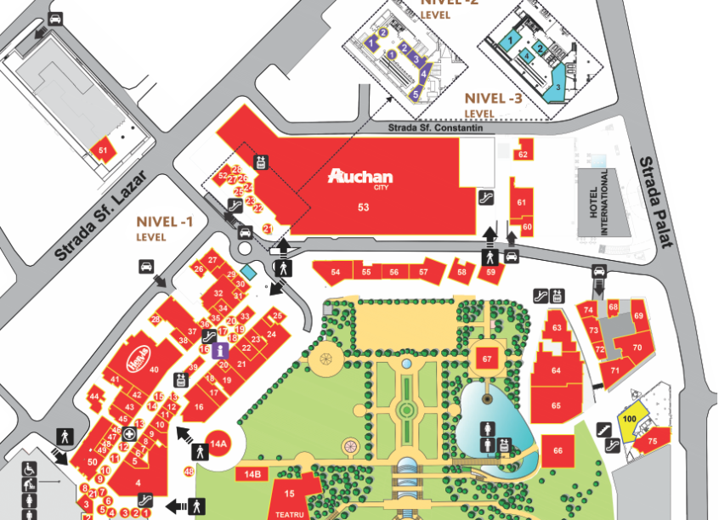

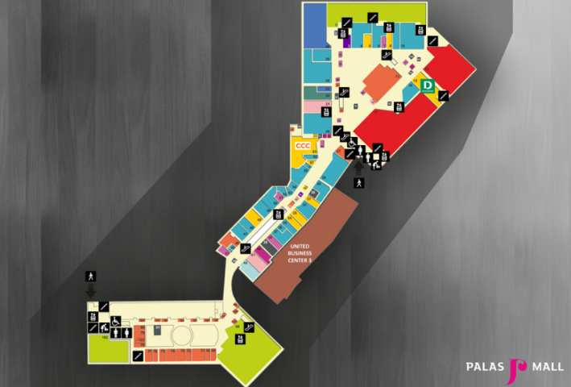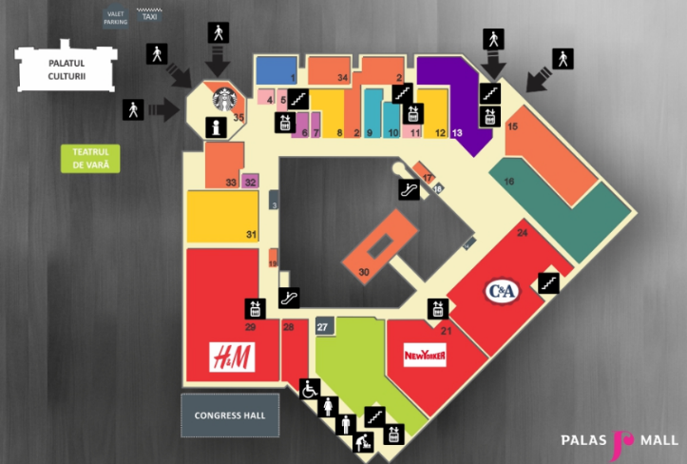

**2nd floor – Congress hall**

**1st floor – Commercial area**

**Ground floor – commercial area, Event area**

**-1st floor – Parking area**

**-2nd floor – Parking area**

**-3rd floor – Commercial area + food area**

**-4th floor – Parking area**

**-5th floor – Parking area**

**Organization Structure :**

Mall Manager

Accountant

Executive

Property Manager

Shift Engineer

HR Manager

Security Executive

Customer care Executive

Staff

Security personnel

**Benefits of public interest**

* Arrangement of a central underground parking with about 2500 parking places
* Highlighting of discovered archaeological remains
* A children's playground
* An outdoor amphitheater
* An outdoor ice rink
* Restoration of the infrastructure in the area
* A public garden
* Preservation of the natural component of the area through the public garden and the green spaces within the complex

**Social Benefits**

* Creation of over 3,000 temporary jobs during construction work
* Creation of over 8,000 permanent jobs after inauguration
* The decrease in the unemployment rate of Iasi
* Capitalizing on the tourist potential of the city
* Attracting new investors
* Improving the degree of economic development of the area

**Development plans**

An investment project of 335 million euros, meaning 1500 underground parking spaces and 10000 new jobs

* Building a office tower behind Palas mall, proposed to be built on a high altitude on the site of the former Petrom which is situated on a medium height, the building will have a triangular shape, placed on the eastern side, near the playground area, there will be a underground building. Architects named it “Cinema Palas” but it will most likely be a multifunctional area.
* An expansion of the Palas garden in 2 zones: towards the Luceafarul Theater and towards the former Petrom. E.ON will be demolished and Palas will have a small extension containing small spaces.
* Saints Andrew’s area will be open to the public with market areas, green spaces, restaurants, cafes and pedestrian areas.

**Network connectivity**

* Individual local servers for remote CCTV monitoring and storage.
* Secured local networks for businesses.
* Publicly available internet hotspots for employees and customers.
* Security cameras placed throughout the mall connected to a main server owned by the Mall.